DATA SCIENCE WITH R_PROGRAMMING
PRACTICAL 1:
Create a supermarket dataframe and perform the following
Code:
# creating dataframe for supermarket data
Super_market <- data.frame(Cus_id = c(01,02,03,04,05,06,07,08,09,10,11,12,13,14,15),

Gender = c("Male", "Female","Male","Male","Female","Female","Male","Female","Female","Male","Female","Male","Female","Female","Male"),

Cus_type = c("Vip","Normal","Vip","Normal","Normal","Vip","Normal","Vip","Normal","Vip","Normal","Normal","Vip","Normal","Normal"),

Payment_Mode = c("E_wallet","cash","cash","cash","E_wallet","E_wallet","cash","cash","","cash","cash","E_wallet","cash","cash","E_wallet"),

Product=c("Electronics","Sports & Travels", "Fashion","Cosmetics","Dairy_products","Electronics","Sports & Travels", "Fashion","Cosmetics","Dairy_products","Electronics","Sports & Travels", "Fashion","Cosmetics","Dairy_products"),

Expenditure = c(200,120,170,190,250,100,140,70,150,110,180,115,175,185,130),

Payment_date= c('2019-04-01','2019-04-01','2019-04-01','2019-04-02','2019-04-02','2019-04-02','2019-04-02','2019-04-02','2019-04-03','2019-04-03','2019-04-04','2019-04-04','2019-04-04','2019-04-05','2019-04-06'),

Ratings = c(5,6,4,7,8,2,5,8,1,10,9,10,9,7,7),

City=c("Mumbai","Delhi", "Pune","Mumbai","Mumbai","Banglore","Mumbai","Pune","Gujarat","Bengal","Mumbai","Mumbai","Delhi","Gujarat","Pune"),

Branch = c("Mumbai","Delhi","Mumbai","Mumbai","Delhi","Mumbai","Delhi","Delhi","Mumbai","Delhi","Delhi","Mumbai","Mumbai","Delhi","Mumbai"))

#viewing the dataframe
View(Super_market)

# Display the "VIP" customers who"s payment mode is E_Wallet
Question1 <- subset(Super_market,Cus_type=="Vip" & Payment_Mode=="E_wallet",select = c(Cus_id,Cus_type,Payment_Mode))
Question1

#Display the "NORMAL" customers who's expenditure is greater than 150
Question2 <- subset(Super_market,Cus_type=="Normal" & Expenditure > 150, select = c(Cus_id,Cus_type,Expenditure))
Question2

#Display the "VIP" customers who payed after date 1at april
Question3 <- subset(Super_market,Cus_type=="Vip" & Payment_date>as.Date("2019-04-01"),select = c(Cus_id,Cus_type,Payment_date))
Question3

# Display the records where the city is mumbai
Question4 <- subset(Super_market,City=="Mumbai")
Question4

#Display the records where the ratings is greater than 8
Question5<- subset(Super_market,Ratings > 8,select = c(Branch,Ratings))
Question5

#Display the records where the product is either "Electronics" or "Sports&Travel" orelse "Fashion"
Question6 <- subset(Super_market,Product=="Electronics" |Product=="Sports&Travel" |Product== "Fashion",)
Question6

#Display the Female "VIP" customers
Question7 <- subset(Super_market,Cus_type=="Vip" & Gender=="Female")
Question7

Output:
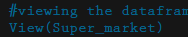
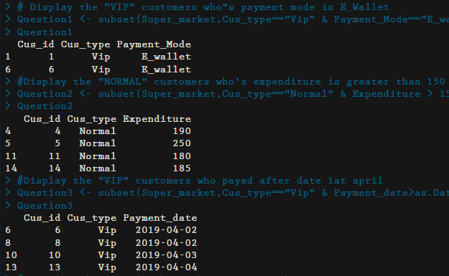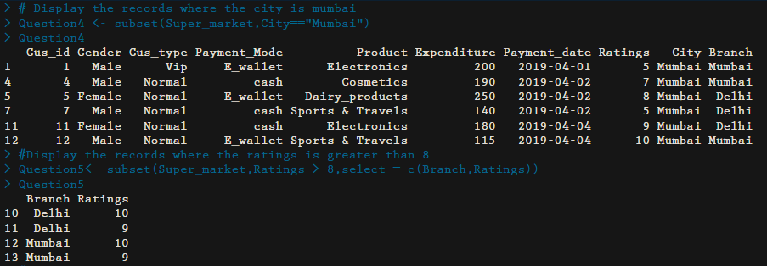
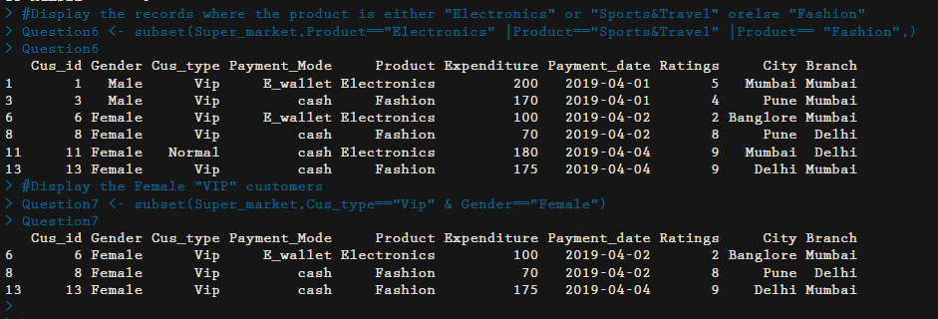
PRACTICAL 2:
Code:

# to create a file
file.create("sample.txt")
# to write data into notepad
write.table(x=iris[1:10,], file='sample.txt')
# to rename the file
file.rename('sample.txt', 'iris.txt')

# to read the table
read.table('iris.txt')

# to list out the files in the directory
list.files()

#to copy the file
file.copy("C:/Users/Muthu Mobiles/Desktop/R studio/iris.txt","C:/Users/Muthu Mobiles/Desktop/")

#creating directory
dir.create("C:/Users/Muthu Mobiles/Desktop/R Dir")
# for copying file to file
file.copy("C:/Users/Muthu Mobiles/Desktop/R studio/iris.txt","C:/Users/Muthu Mobiles/Desktop/R Dir")

file.create("student.csv")

write.csv(data.frame(roll_no=c(1,2,3,4,5),Name=c('Mano','Arvind','Suthaker','Anjali','Aruna'),course=c('DS','CS','DS','CS','IT'),Semester=c(1,2,2,3,1)), file="student.csv")
#read csv
read.csv("student.csv")
#read csv
data <- read.csv("student.csv")
print(is.data.frame(data))

print(nrow(data))
print(ncol(data))
data

Output:
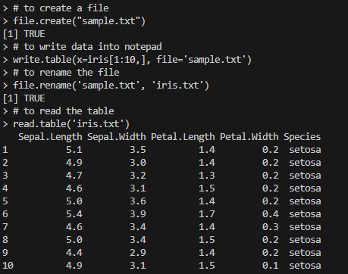
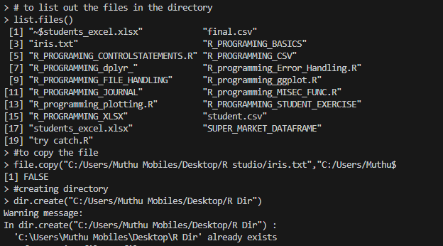
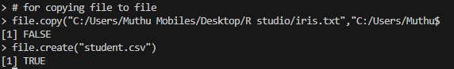

PRACTICAL 3:
Reading csv files
Code:
# to read the csv file
r_csv <- read.csv("employeedata.csv") #replace your csv location or name

# to remove the unwanted column [refers to row index,refers to column index]
r_csv <- r_csv[,-1]

#to view the csv file
View(r_csv)

#question 1: Display the records in which the gender is "male" and city is "pune"
male_emp <- subset(r_csv, Gender=="M" & City == "Pune", select = c(emp_ID,emp_name,Gender,City))
male_emp

#question 2: Display the records in which the gender is "female" and city is "pune"
female_emp <- subset(r_csv, Gender=="F" & City == "Pune", select = c(emp_ID,emp_name,Gender,City))
female_emp

#question 3: Calculate the experience of the employee in years and write it in new csv file
current_date <- Sys.Date() # for storing the current date
exper <- difftime(current_date,as.Date(r_csv$Joning_date )) #for difference the current date with joining date
exper #for viewing the output
r_csv$experiance <- as.numeric(exper)%/%365.25 # for converting days to years and storing to new column "experience"
r_csv # for viewing the output

#optional method
r_csv$exp_month <- as.numeric(u_csv$experiance)*12 #for converting days to months and storing to new column "exp_month"
r_csv #viewing the output

write.csv(r_csv,"final.csv") # to write the experience in new csv file "final.csv"
u_csv <- read.csv("final.csv") # to read the written csv called final.csv
u_csv <- u_csv[,-1]
u_csv$experiance # accessing the experience column

#question 4:display the employees who are working in either sales team or operations or marketing
sales_Oper_Market <- subset(u_csv, Department %in% c("Marketing","Sales","Operation"))
sales_Oper_Market

#question 5:display the highest salary in sales team
sales_data <- subset(u_csv,Department=="Sales") #storing sales column data from u_csv in sales_data

# to find the highest salary in sales department
high_sal_sales <- subset(sales_data,Salary== max(Salary),select =c(1,2,4,6))
high_sal_sales

#question 6:display the maximum salary in pune city
city_data <- subset(u_csv,City=="Pune") #storing city column data from u_csv in city_data

# to find the highest salary in pune city
high_sal_pune <- subset(city_data, Salary==max(Salary)&City=="Pune",select =c(1,2,4,6))
high_sal_pune

#question 7:display the minimum salary in pune city
min_sal_pune <- subset(city_data,Salary==min(Salary),select =c(1,2,4,6))
min_sal_pune

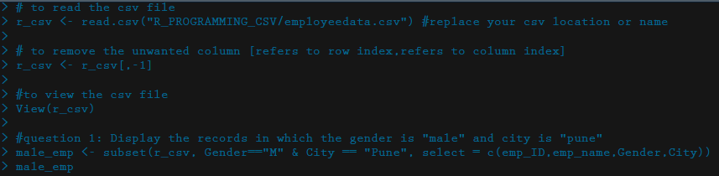
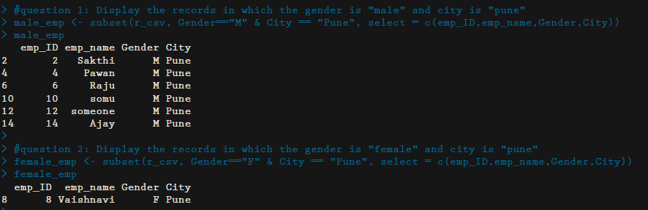
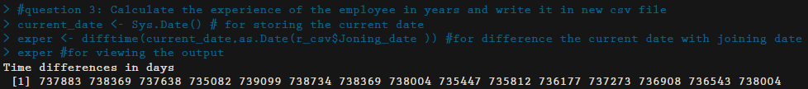
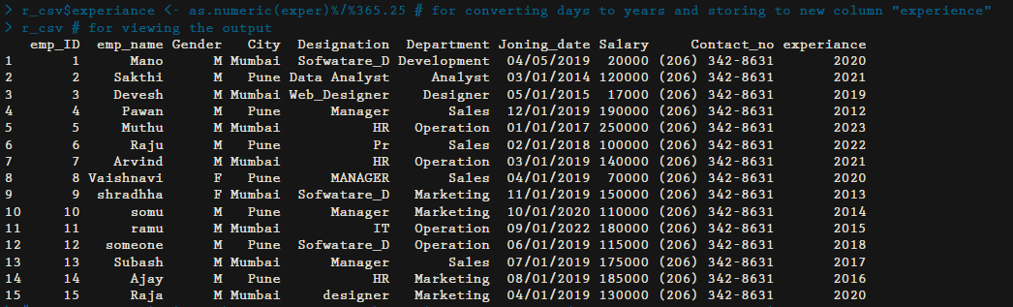
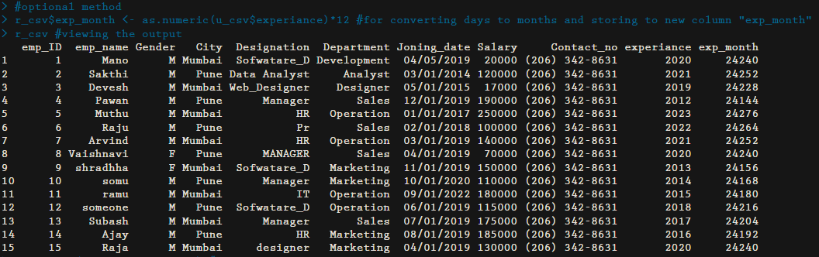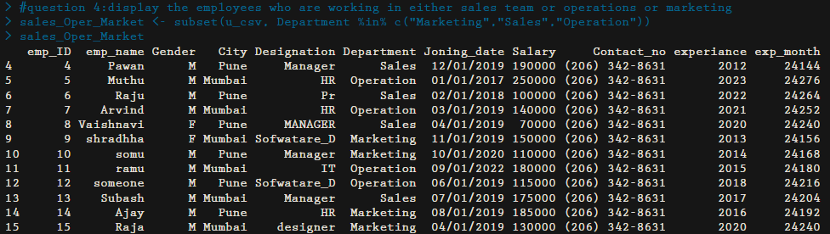
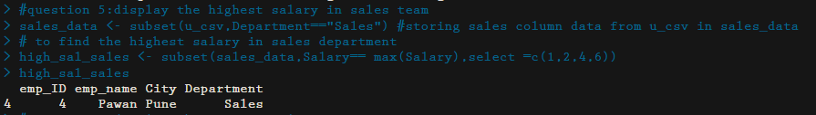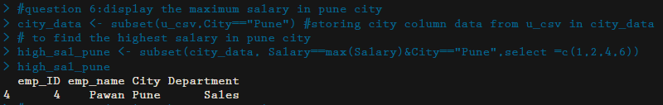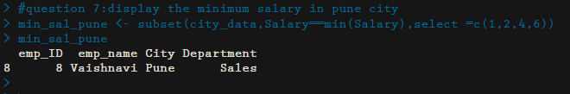

PRACTICAL 4:
R_Programming dplyr package
Code:
library(dplyr)

getwd()
setwd("C:/Users/Muthu Mobiles/Desktop/R studio")

data <- read.csv("R_programming_dplyr_/product_data.csv")
data

#1. Display the records except price and quantity
select(data, -c(Product_price,qty))
#2.Display the records ends_with "y"
select(data, ends_with("y"))
#3. Display the records starts_with "c"
select(data, starts_with("c"))
#4. DIsplay the quantity greater than 100
qty_f <- filter(data, qty > 100)
qty_f
#5.Display the record quantity in descending order
arr_qty_desc <- arrange(data, desc(qty))
arr_qty_desc
#6.Display the records in ascending order
arr_qty_asc <- arrange(data, qty)
arr_qty_asc
#7.Display the first 6 records
head(select(data,c(Product_ID:category )),6)
#8.Display the last 6 records
tail(select(data,c(Product_ID:category)),6)
#9.Renaming the column name
name_change <- rename(data, product_qty=qty)
name_change
#10.Caluculating the total cost using mutate function
mutate_data <- mutate(data, Total_price = Product_price*qty)
mutate_data
#11.Calcuulating the total cost using transmute function
trans_mute <- transmute(data, Total_price = Product_price*qty)
trans_mute
#12.Slicing the data
sliced <- slice(data, -c(2:6))
sliced
#13.Remove duplicate row
Unique_records <- unique(data, incomparables = FALSE)
Unique_records
#14.Display any random 4 records
random_data = sample_n(data,4)
random_data
#15.Display random 50% of the given dataset
half_random_data = sample_frac(data,0.60)
half_random_data
#16 Find out total product in each category
grp_prod <- data %>% group_by(category) %>% count(category)
grp_prod
#17 find max and min price of product for each category
summ_prod <- data %>% group_by(category) %>%summarise(max_price = max(Product_price), min_price = min(Product_price))
summ_prod
#18display the product details which has the maximum price
max_price <- slice_max(data,order_by = Product_price)
max_price

Output:
> library(dplyr)
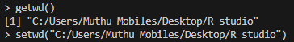
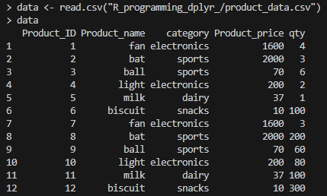

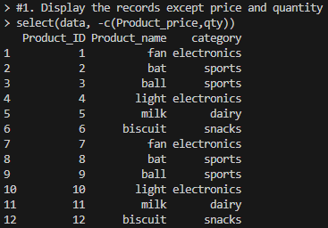

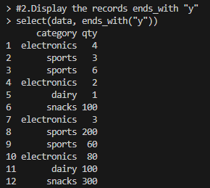

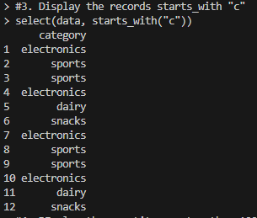

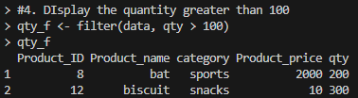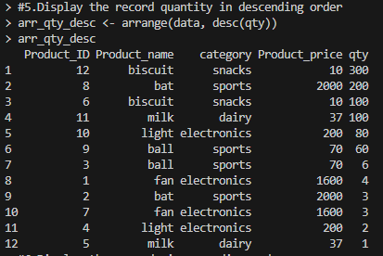
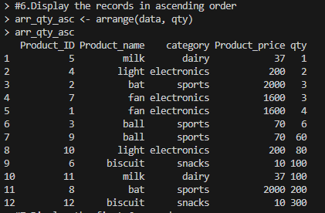
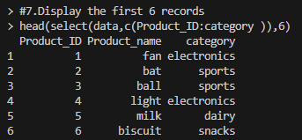
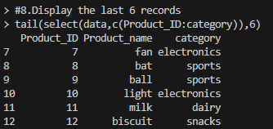
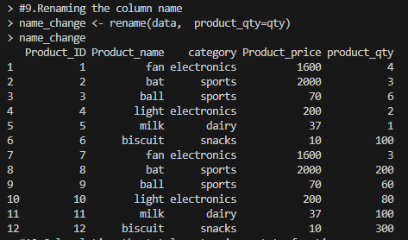
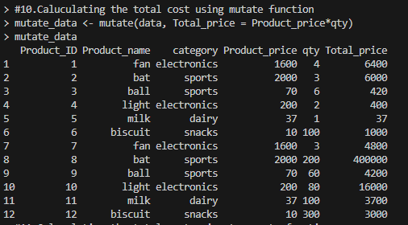
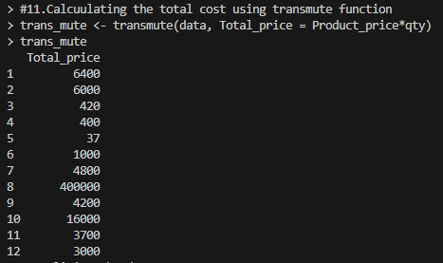
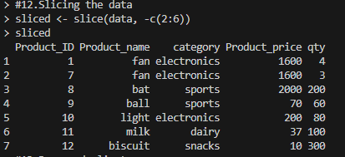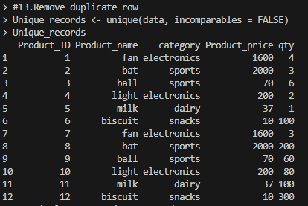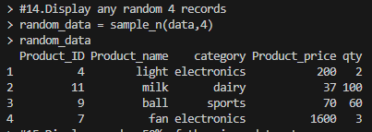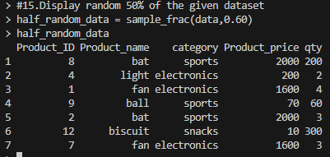
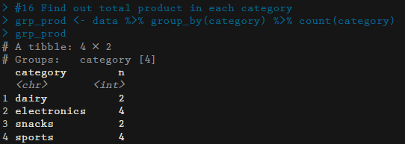
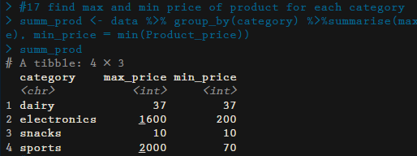
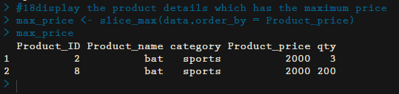
PRACTICAL 5:
Create a student csv file which has the fields like roll_no, class, semester, division, mark1, mark2, mark3, department
Code:
getwd()
setwd("C:/Users/Muthu Mobiles/Desktop/R studio")
library(dplyr)
library(xlsx)
data <- read.csv("student.csv")
data

#Q1
data <- mutate(data, Total = subject_1+subject_2+subject_3)
data

#Q2

data <- mutate(data, Percentage = paste0(round((Total/300)*100),"%"))
data
#Q3
data <- mutate(data, Grade = case_when(Percentage>=90~"A",
Percentage>=80 & Percentage<90 ~"B",
Percentage>=70 & Percentage<80 ~"C",
Percentage>=60 & Percentage<70 ~"D",
Percentage>=45 & Percentage<60~"E",
Percentage<45~"Fail"))
data
#Q4 max marks in each department
max_marks <- data%>%group_by(Department)%>%summarise(max_marks=max(Total))
max_marks

#Q5
data_ds <-data%>%filter( Department == "DataScience")%>%filter(Total == max(Total))
data_ds

#Q6
high_marks_sub_3 <- filter(data,subject_3==max(subject_3))
high_marks_sub_3

#Q7
total_count <- data%>%group_by(Department)%>%count(Department)
total_count

#Q8
data_ds <-data%>%filter( Department == "DataScience")%>%filter(Grade=="F")
data_ds
#Q9 f from each ddept
f_marks <- data%>%group_by(Department)%>%filter(Grade=="F")%>%count(Department)
f_marks
#Q10
random_data <- data%>%filter(Department == "Information Technology")%>%sample_n(5)
random_data

#Q11
write.xlsx(data,"students_excel.xlsx", row.names = FALSE)

Output:
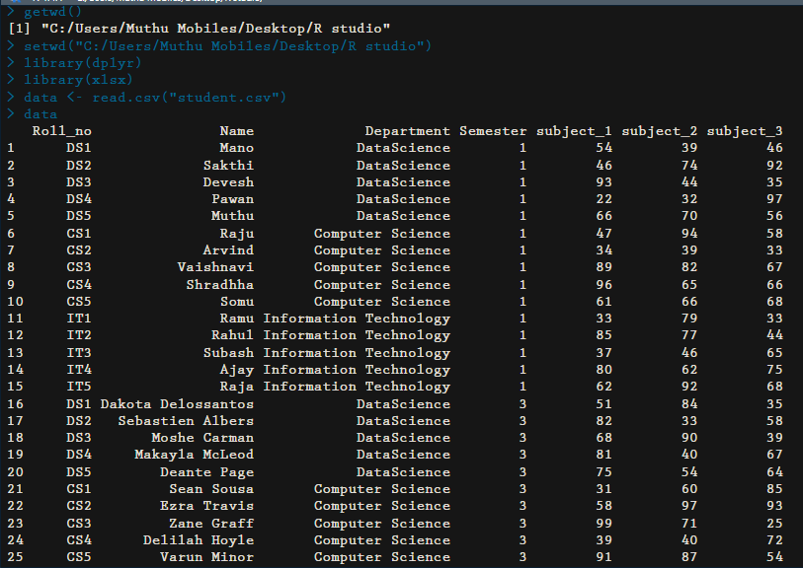
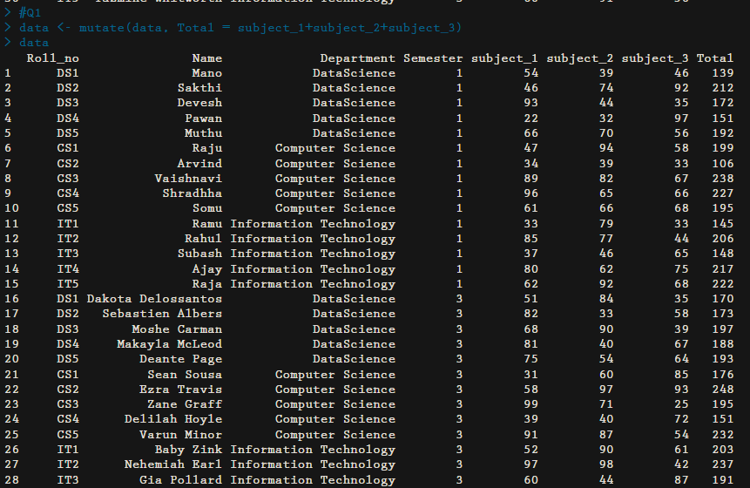
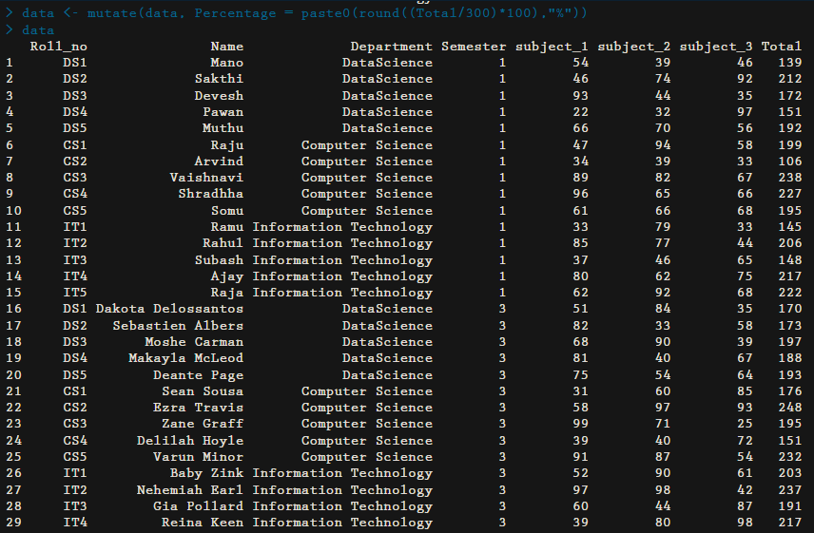
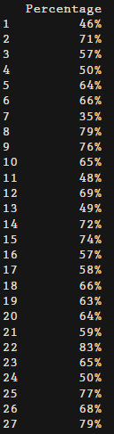
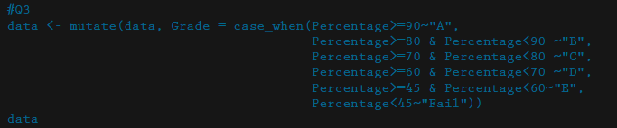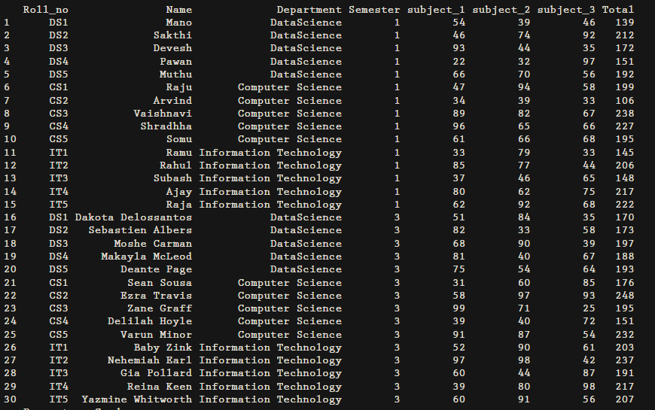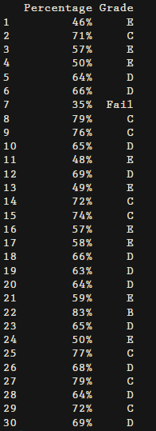
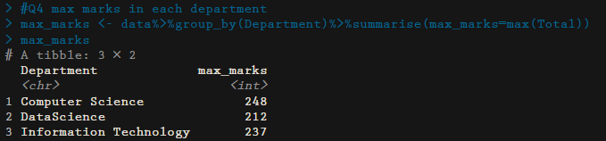
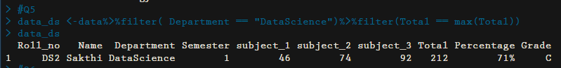
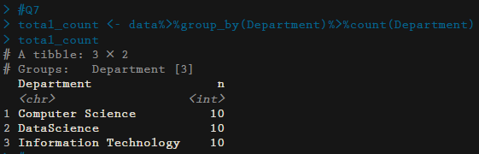
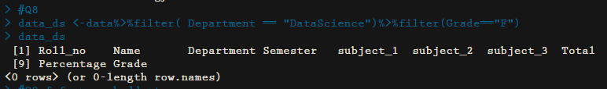
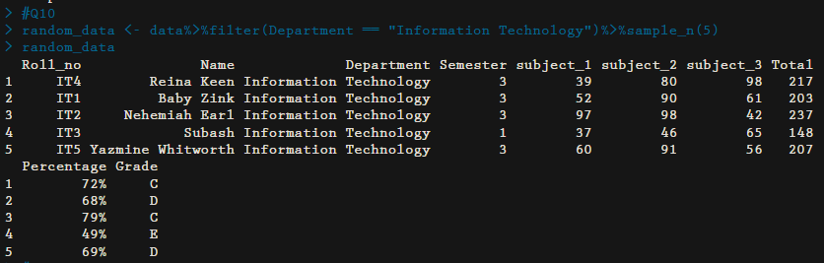
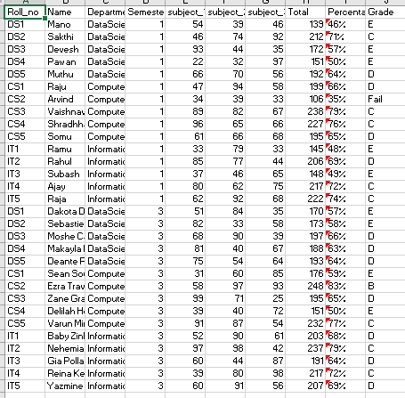

PRACTICAL 5:
Apply() Family in R
Code:
# APPLY FAMILY IN R
#apply function()
sample_matrix <- matrix(c<-(1:10),nrow=3,ncol=10)
print("sample matrix")
sample_matrix

print("sum across rows")
apply(sample_matrix,1,sum)

print("mean across columns")
apply(sample_matrix,2,mean)

print("mean across rows")
apply(sample_matrix,1,mean)

#lapply function(for list)
names <- c("sapna","shivani","krishna","gayu")
print("original data:")
names

print("data after laaply():")
lapply(names,toupper)

print("data after laaply():")
lapply(names,tolower)

#sapply() function
sample_data <- data.frame(x=c(1,2,3,4,5,6),
y=c(3,2,4,2,34,5))
print("original data:")
sample_data

print("Data after sapply():")
sapply(sample_data,max)

print("Data after sapply():")
sapply(sample_data,min)

#tapply
data <- data.frame(name=c("amy","max","ray","kim","sam","eve","bob"),
age=c(24,22,21,23,20,24,21),
gender=factor(c("F","M","M","F","M","F","M")))
print("original data")
data
tapply(data$age,data$gender,min)

#using tapply function find out highest salary of employee department wise.
data <- data.frame(name=c("amy","max","ray","kim","sam","eve","bob"),
salary=c(24000,22000,21000,23000,20000,24000,20000),
department=factor(c("IT","DS","CS","BT","CS","DS","IT")))
data
tapply(data$salary,data$department,max)

#tapply for mtcars
y <- data.frame(mtcars)
y
tapply(y$mpg,list(y$cyl,y$am),mean)

#tapply use for sepal length
iris
tapply(iris$Sepal.Length,iris$Species,mean)

#mapply
A = list(c(1,2,3,4))
B = (c(2,5,1,6))
result = mapply(sum,A,B)
print(result)

#mapply function with multiple arguments.
Data1 <- c(1,2,3)
Data2 <- c(10,20,30)
mult_one <- function(Data1,Data2)
{
Data1 + Data2
}
mapply(mult_one,Data1,Data2)

Output:
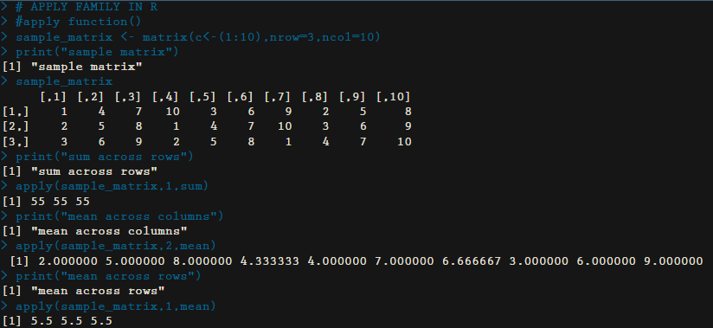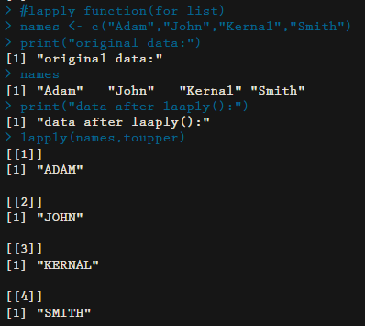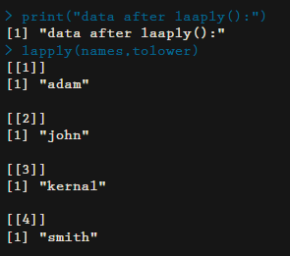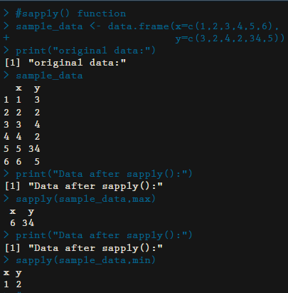
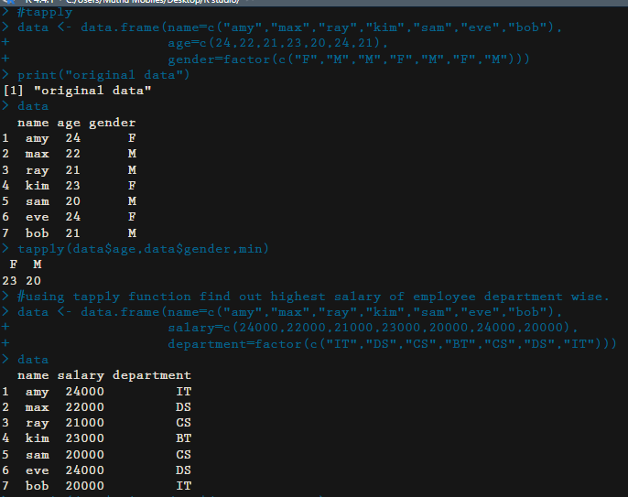
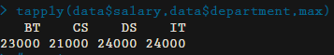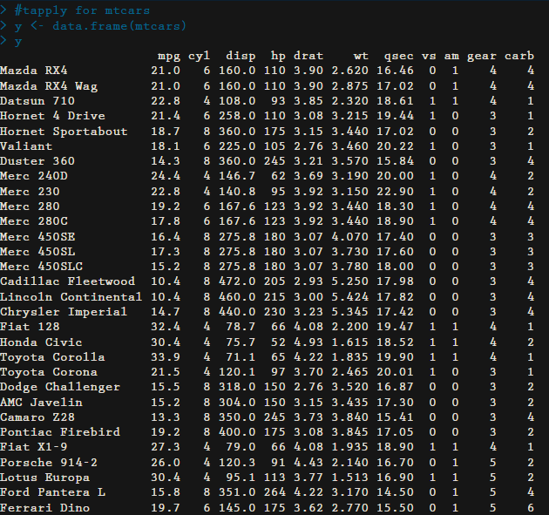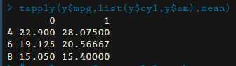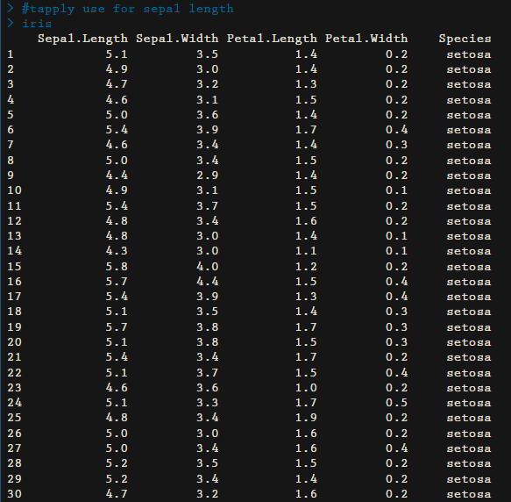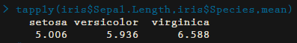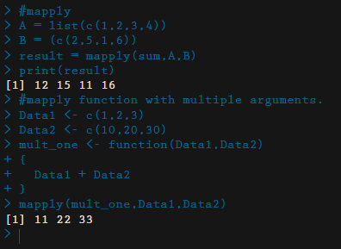

PRACTICAL 6:
Control Statements
Code:
# CONTROL STATEMENTS
# if statement
x <- 3
if (x>0){
print("The number is positive")
}
print("outside if statement")

# if....else statement
x <- 12
if (x>0){
print("x is a positive number")
} else{
print("x is a negative number")
}

# if....else if....else statement
x <- 0
if(x>0){
print("x is a positive number")
} else if (x<0){
print("x is a negative number")
} else{
print("x is zero")
}

# Nested if....else statement
x <- -20

if (x > 0) {

if (x %% 2 == 0) {
print("x is a positive even number")
} else {
print("x is a positive odd number")
}

} else {

if (x %% 2 == 0) {
print("x is a negative even number")
} else {
print("x is a negative odd number")
}
}

# ifelse function
# create a vector to check the number are even or odd using if...else function
x <- (1:10)
x
ifelse((x %%2 == 0),"even","odd")

marks <- c(63,65,29,19,48)
ifelse((marks<40), "FAIL","PASS")

# switch function
switch(1,"red","green","pink")
switch(5,"a","b","c","d","f")

# for loop function
fruit<-c("Apple","Orange","Guava","Pineapple","Banana","Grapes")
for(i in fruit){
print(i)
}

# using for loop count how many even number from integer vector
A <- c(1,5,4,7,8,10,4,7,3,18)
even_count <- 0
odd_count <- 0
for(i in A){
if(i%%2 == 0){
even_count <- even_count+1

}else{
odd_count <- odd_count+1
}
}
print(even_count)
print(odd_count)

#matrix
mat <- matrix(21:32,nrow=6,ncol=2)

for (r in 1:nrow(mat))
{
for (c in 1:ncol(mat))
{
cat(mat[r,c]," ")
}
cat("\n")
}
####
mat <- matrix(21:32,nrow=6,ncol=2)

for (r in 1:nrow(mat))
{
for (c in 1:ncol(mat))
{
cat(mat[r,c]+20," ")
}
cat("\n")
}

# R repeat loop
v <- c("Hello","Repeat","loop")
cnt <- 2
repeat{
print(v)
cnt <- cnt+1
if (cnt>5){
break
}
}

#while loop
y <- c("Hello","while loop","example")
cnt <- 2
while(cnt < 7){
print(y)
cnt = cnt+1
}

# R next statement
val <- 6:11
for(i in val)
{
if(i == 8)
{
next
}
print(i)
}

# R break statement
val <- 6:11
for(i in val)
{
if(i == 9)
{
break
}
print(i)
}

Output:
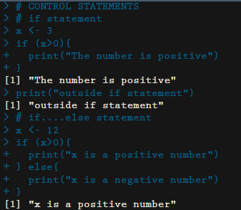
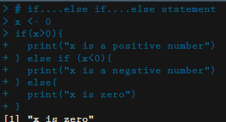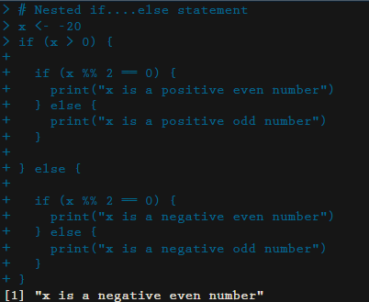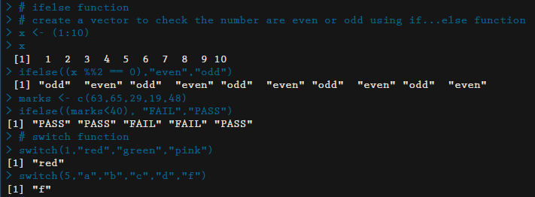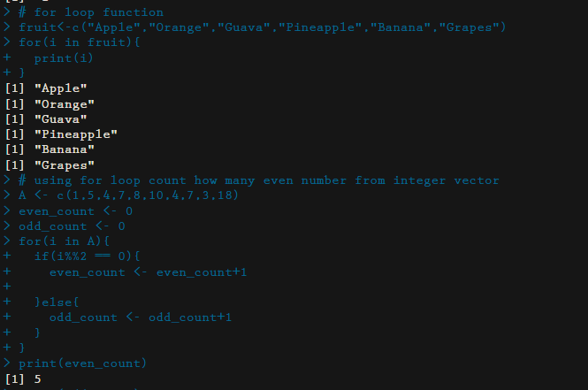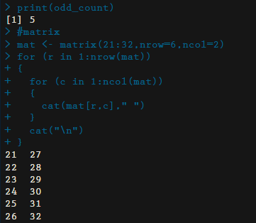
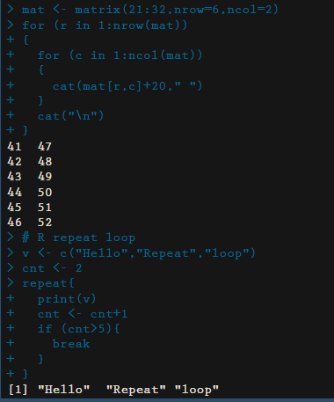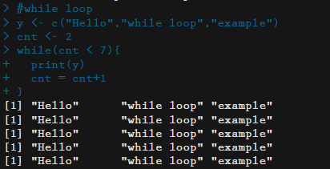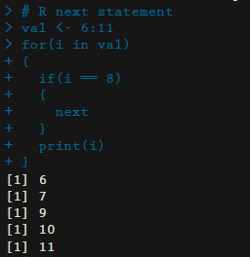
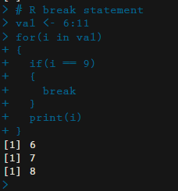

PRACTICAL 6:
Functions
Code:
getwd()
read_func <- function(file){

if(file.exists(file)){

read.csv(file)

} else{

print('File Doesnt Exist!')

}

}

read_func(file = "student.csv")

content <- read.csv("Empdata.csv")

content

write_func <- function(file,content){

if(file.exists(file)){

write.table(content, file, append=TRUE)

} else{

print("created new file to write")

write.csv(content, file)

}

}

write_func('employee.csv', content=content)

search_students <- function(file,dept){
if(file.exists(file)){
read_file <- read.csv(file)
match <- subset(read_file,Department==dept)
match
} else{
print("Error in fetching")
}

}
search_students("student.csv","DataScience")

max_salary <- function(myfile,dept){
if(file.exists(myfile)){
data <- read.csv(myfile)
department <-filter(data,Department==dept)
max_sal <- department%>%filter(Salary == max(Salary))
max_sal
} else{
print("Error")
}

}
max_salary("Empdata.csv","Sales_team")

Output:
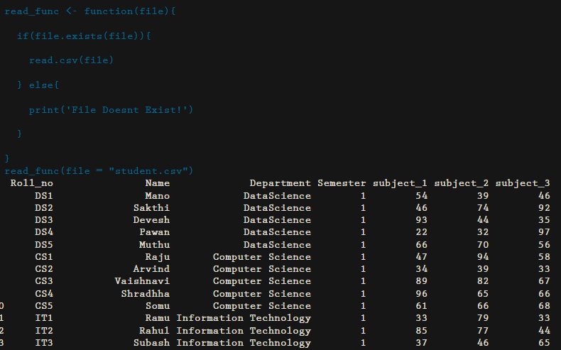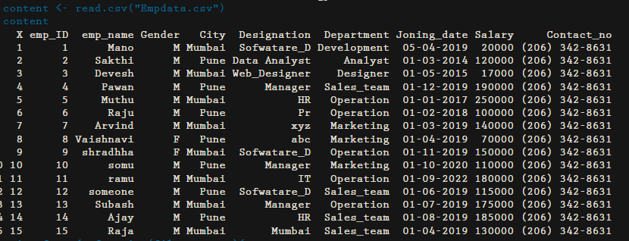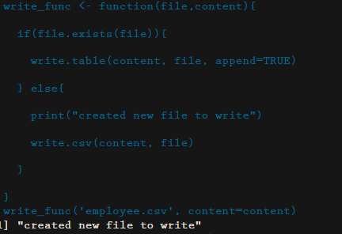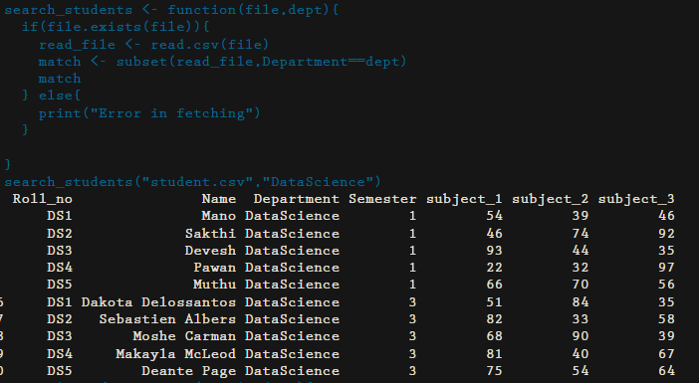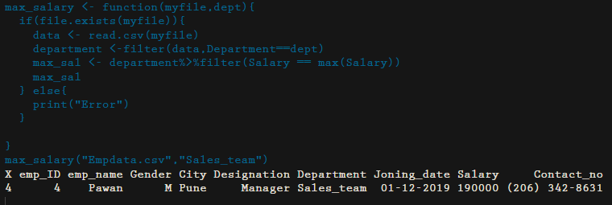
PRACTICAL 7:
Dput, dget, dump, source, load, save, saveimage, serialize, unserialize
Code:
getwd()
setwd( "C:/Users/sies/Documents/")
a <-1:10
a
x <- data.frame (Name =c('rahul','vishwa'),age =c(19,18),gender=c('male','male'))
dput(x,"meta.txt")
y <-mtcars
dget("meta.txt")
dump(c('x','y'),file="dump_data.R")
source("dump_data.R")
save(x,y,file="sampledata.rda")
load("sampledata.rda")
save.image("binarydata.R")
load("binarydata.R")
x <-list(1,2,3)
s <- serialize(x,NULL)
save(s,file="serialize_data.txt")
load("serialize_data.txt")
unserialize(s)

###########tapply
employee_data <-data.frame(employeeid=c(1:10),
department=c("HR","IT","IT","data science","CS","data science","HR","data science","HR","CS"),
salary=c(20000,30000,50000,45000,85000,90000,940000,78000,60000,54000))
print(employee_data)
max <-tapply(employee_data$salary,employee_data$department,max)
print(max)

Output:
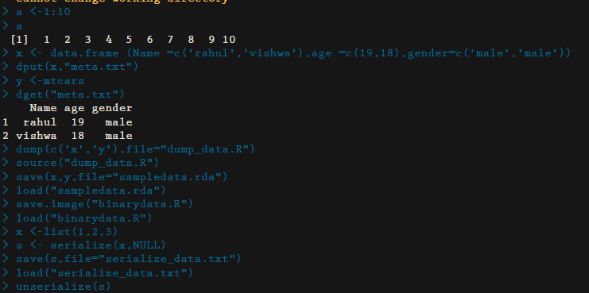

PRACTICAL 8:
ERROR HANDLING
CODE:
#Question 2
#make a function, accept a number as argument, if number is even print even, if number is odd print odd otherwise throw an error
even_odd <- function(num) {
tryCatch(
{

if (num%%2==0) {
print("Even Number")
}else{
print("Odd Number")
}
},

error = function(e) {

message('An error occured:', e ,'Value must be a number')

},
warning = function(w){

message('Warning:', w)

},

finally = {

message('Finally Done!')

}

)

}

# Call the function
#valid
even_odd(3)
even_odd(2)
#invalid
even_odd("a")

#Question 2
# make a function, accept a vector of names as argument, if strings are valid then convert to upper case, otherwise throw error

to_upper <- function(vector) {
tryCatch(
{
if (!is.character(vector)) {
stop("Input must be a character vector.")
}
uppercase_names <- toupper(vector)
return(uppercase_names)
},error = function(e) {
return(paste("Error:", e$message))
}
)
}

names <- c("jhon", "doe", "adam", "mano", "ajay")
print(to_upper(names))

numeric_input <- 12345
print(to_upper(numeric_input))

#vaild
to_upper("sies")

#invalid
to_upper(123)

Output:
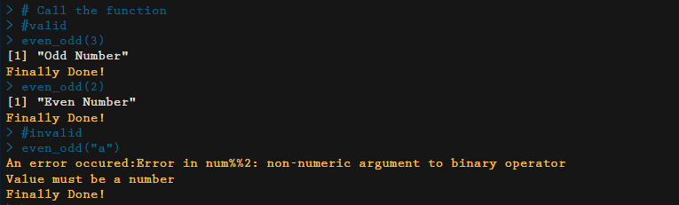
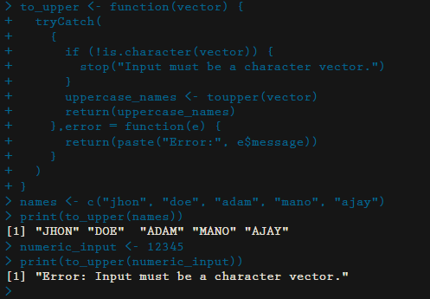
PRACTICAL 9:
Basic plotting
Code:
plot(1,3)
plot(c(1, 8), c(3, 10))
plot(c(1, 2, 3, 4, 5), c(3, 7, 8, 9, 12))
x <- c(1,2,3,4,5)
y <- c(3,7,8,9,12)
plot(x,y)

plot(1:10)
plot(1:10, type="l")
plot(1:10, main="My Graph", xlab="The x-axis", ylab="The y axis")
plot(1:10, col="red")
plot(1:10, cex=2)
plot(1:10, pch=25, cex=2)
plot(1:10, type="l", lwd=2)
plot(1:10, type="l", lwd=5, lty=3)

line1 <- c(1,2,3,4,5,10)
line2 <- c(2,5,7,8,9,10)

plot(line1, type = "l", col = "blue")
lines(line2, type="l", col = "red")
# Create a vector of pies
x <- c(10,20,30,40)

# Display the pie chart
pie(x)

# Create a vector of pies
x <- c(10,20,30,40)

# Display the pie chart and start the first pie at 90 degrees
pie(x, init.angle = 90)

# Create a vector of pies
x <- c(10,20,30,40)

# Create a vector of labels
mylabel <- c("Apples", "Bananas", "Cherries", "Dates")

# Display the pie chart with labels
pie(x, label = mylabel, main = "Fruits")

# Create a vector of colors
colors <- c("red", "yellow", "pink", "brown")

# Display the pie chart with colors
pie(x, label = mylabel, main = "Fruits", col = colors)

# Create a vector of labels
mylabel <- c("Apples", "Bananas", "Cherries", "Dates")

# Create a vector of colors
colors <- c("red", "yellow", "pink", "brown")

# Display the pie chart with colors
pie(x, label = mylabel, main = "Pie Chart", col = colors)

# Display the explanation box
legend("bottomright", mylabel, fill = colors)

Output:
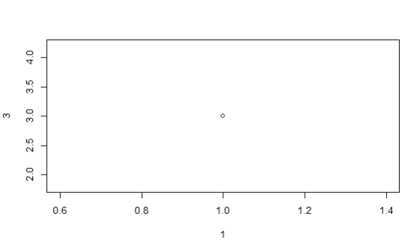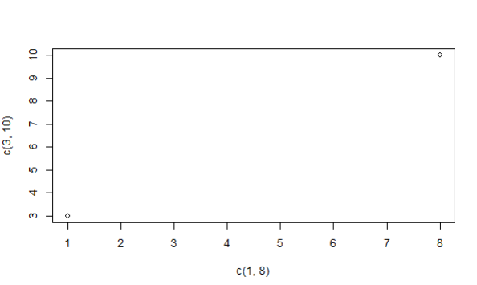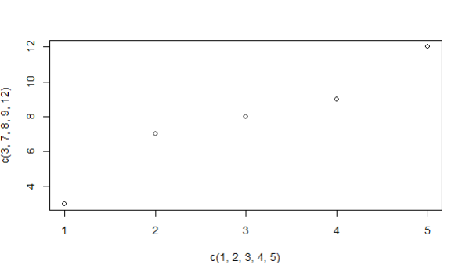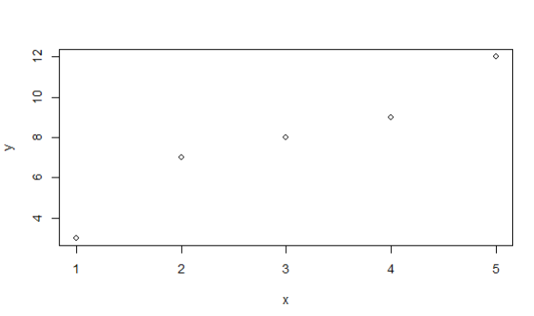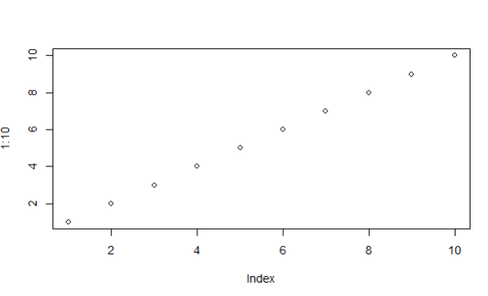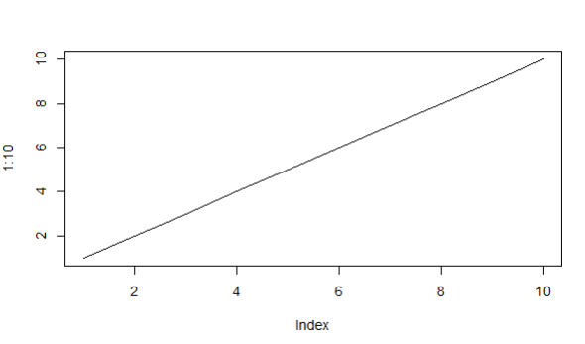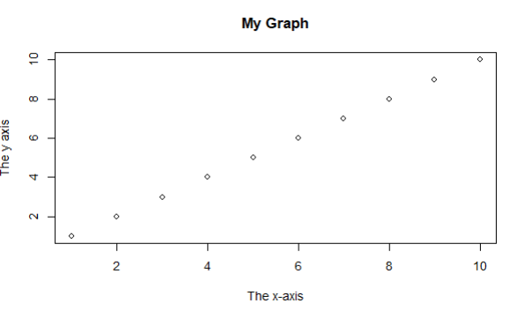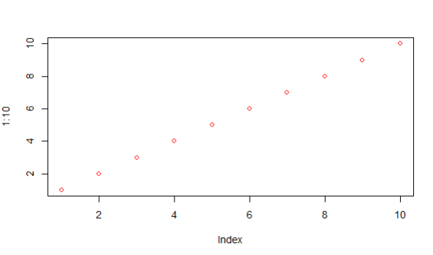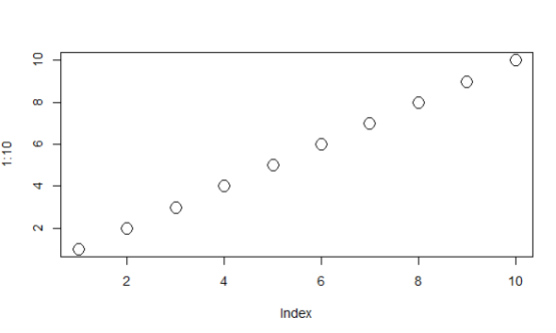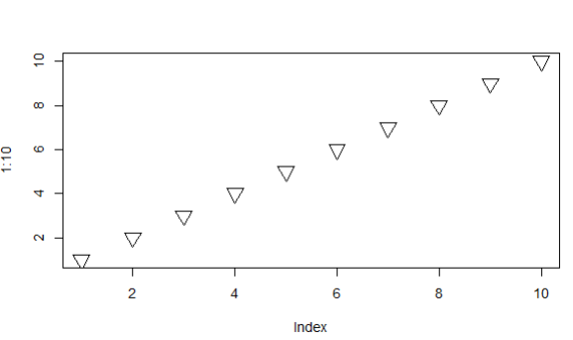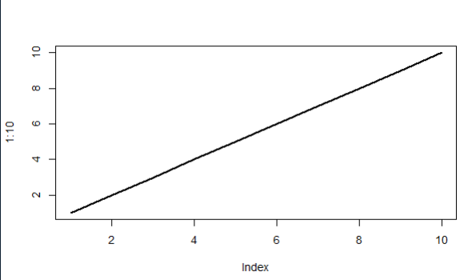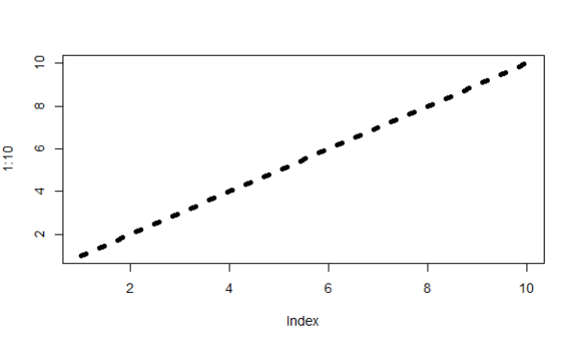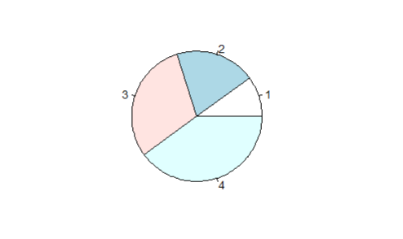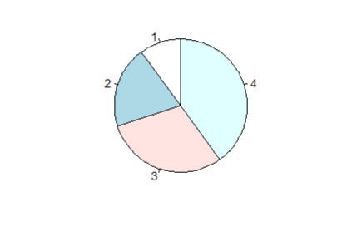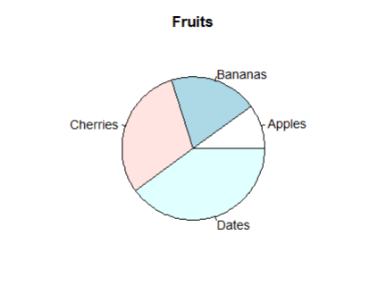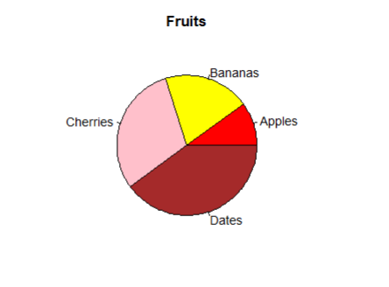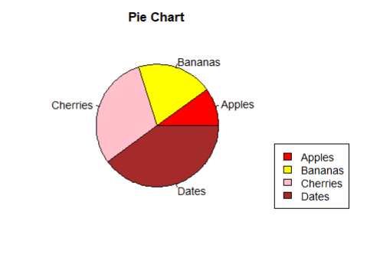

PRACTICAL 10:
Ggplot2 in R
Code:
install.packages('ggplot2')
library(ggplot2)
ggplot(iris, aes(x=Sepal.Length, y=Petal.Length, col = Species, shape = Species))+geom_point()
ggplot(data = mtcars, mapping = aes(x=mpg, y=disp))+geom_point()

ggplot(mtcars, aes(x=mpg, y=hp,col = gear))+geom_point()

library()
student <- read.csv('student.csv')
ggplot(student, aes(x=Roll_no,y = subject_1, col=Semester, shape=Department))+geom_point()

ggplot(student,aes(x=subject_1, col=Department)) + geom_bar()

Output:
